Guangzhou BRT
Program Area: Developing High-Quality, Low-Cost Mass Transit
Country: China
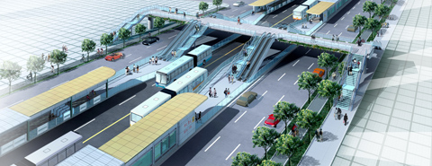
BRT Station rendering (Source: ITDP / GMTDC)
In 2007 Guangzhou, a city of 10 million, carried out the detailed engineering design and some preliminary road works of a Bus Rapid Transit system which is likely to be operational late in 2008.
Planned by ITDP together with the Guangzhou Municipal Technology Development Corporation, Guangzhou’s BRT system stands to rival the renowned TransMilenio system of Bogotá, Colombia by delivering average bus speeds of more than 25 kilometers (15.5 miles) per hour, and carrying more than 25,000 riders per hour in one direction at peak periods.
This is more than double the passenger capacity, delivered at a higher speed and under better service conditions, than any other existing or planned BRT system in Asia. In contrast to TransMilenio, Guangzhou’s BRT buses will also operate outside the busway, eliminating the time and inconvenience of transfers.
The first corridor will be 23 kilometers long (14.3 miles) with 29 stations, starting from the city centre and extending eastward along Zhongshan Avenue. More than 600,000 daily passengers will use the first BRT corridor. Commuters traveling along the full corridor into the city centre in the morning and returning in the evening will save one hour in travel time each day. Total passenger time savings from the new system will exceed 100,000 hours each day, or more than 36 million passenger-hours each year.
For more information about this project contact:
Karl Fjellstrom
karl@itdp.org
or visit:
www.gzbrt.org

